**Experiment No. 1.3**

**Student Name:** GauravKumar **UID:** 22MCC20177

**Branch:** MCA **-** CCD **Section/Group:** 22MCD1 **/** GrpA

**Semester:** II **Date of Performance:** 07th March 2023

**Subject Name:** Advanced Internet Programming Lab **Subject Code:** 22CAP-686

1. **Aim/Overview of the practical:**

**Task to be done:**

1. **Write a servlet to display current time and refresh at every 5 seconds.**
2. **Write a servlet to forward a request to another Servlet.**
3. **Code for experiment/practical:**
   1. **Servlet to display current time and refresh at every 5 seconds.**

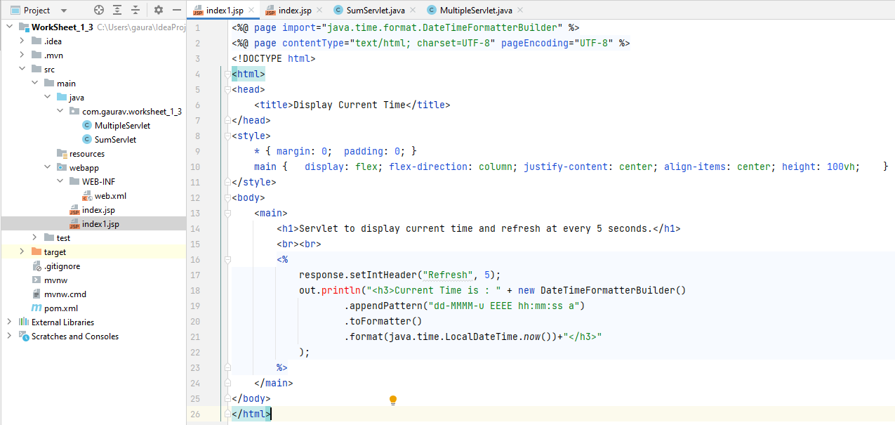

* 1. **Servlet to forward a request to another Servlet.**

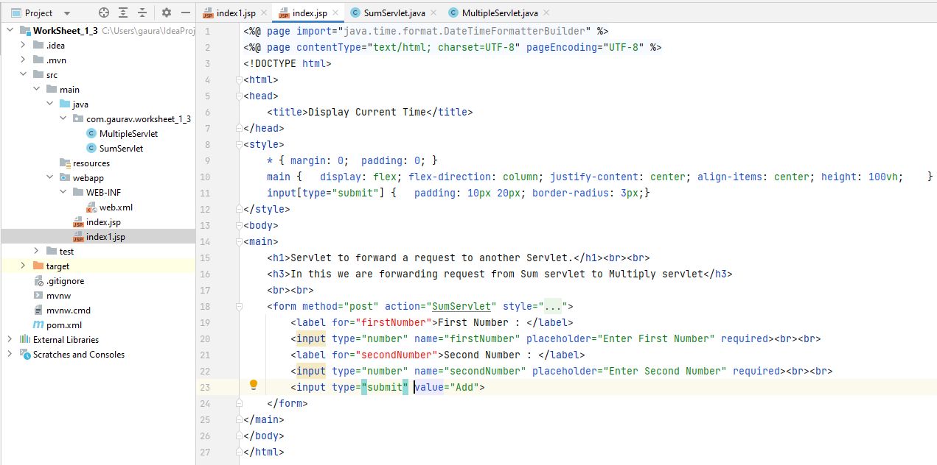

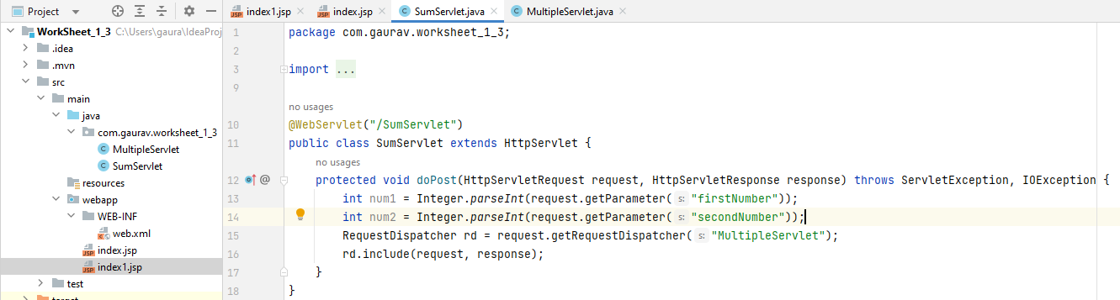

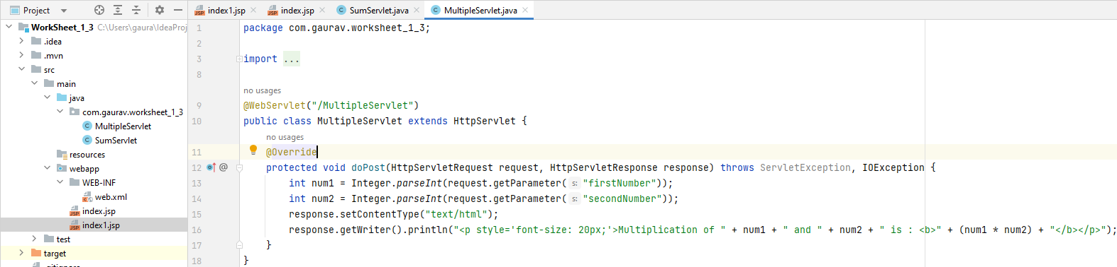

1. **Result/Output/Writing Summary:**
   1. **Index.jsp**

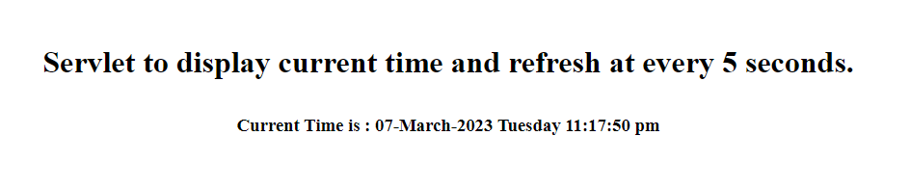

* 1. **Index.jsp**

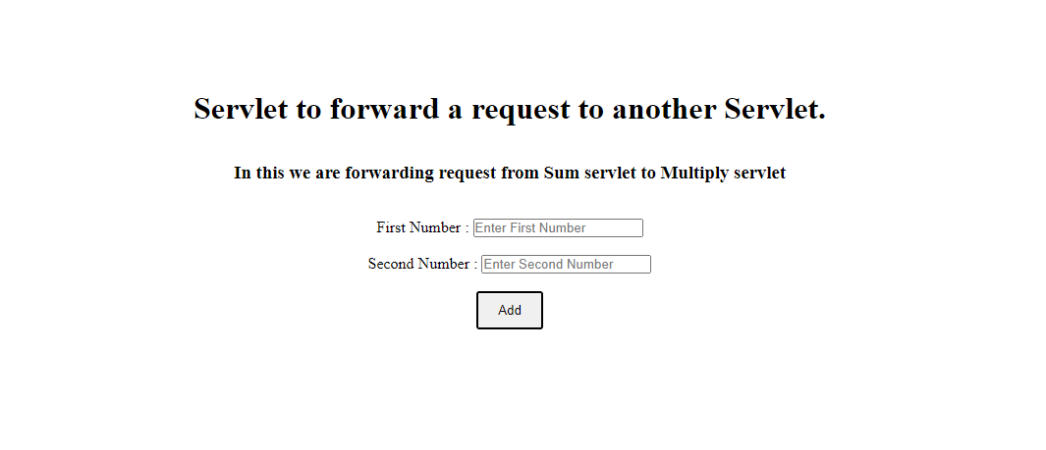

**SumServlet => MultipleServlet**



**Learning outcomes (What I have learnt):**

**1. Learn about Date class and setIntHeader() function.**

**2. Learn about RequestDispatcher Class.**

1. **Evaluation Grid:**

|  |  |  |  |
| --- | --- | --- | --- |
| Sr. No. | Parameters | Marks Obtained | Maximum Marks |
| 1. | Demonstration and Performance (Pre Lab Quiz) |  | 5 |
| 2. | Worksheet |  | 10 |
| 3. | Post Lab Quiz |  | 5 |